 



Database Programming with SQL 3-3: Introduction to Functions Practice Activities

# Objectives

* Identify appropriate applications of single-row functions in query statements
* Classify a function as a single-row or multi-row function
* Differentiate between single-row functions and multirow functions and the result returned by each

# Try It / Solve It

1. For each task, choose whether a single-row or multiple row function would be most appropriate:
   1. Showing all of the email addresses in upper case letters single row
   2. Determining the average salary for the employees in the sales department multiplie row
   3. Showing hire dates with the month spelled out *(September 1, 2004) single row*
   4. Finding out the employees in each department that had the most seniority (the earliest hire date) multiple row
   5. Displaying the employees’ salaries rounded to the hundreds place single row
   6. Substituting zeros for null values when displaying employee commissions. single row

1. The most common multiple-row functions are: AVG, COUNT, MAX, MIN, and SUM. Give your own definition for each of these functions.

AVG- среднее значение.

COUNT- колчиество элементов

MAX- максимальный (наибольший) элемент

MIN- минимальный (наименьший) элемент

SUM- сумма элементов

1. Test your definitions by substituting each of the multiple-row functions into this query.

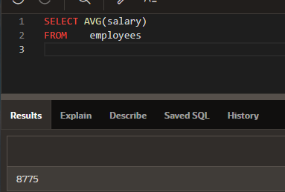

SELECT FUNCTION(salary)

FROM employees

Write out each query and its results.

AVG = 8775

COUNT = 20

MAX = 24000

MIN = 2500

SUM = 175500

Copyright © 2020, Oracle and/or its affiliates. All rights reserved. Oracle and Java are registered trademarks of Oracle and/or its affiliates. Other names may be trademarks of their respective owners.